**5th GRADE PARENT NEWSLETTER**

Dear parents,

*Our school is an IB (International Baccalaureate) school and we are preparing our students to become citizens of the world.*

This year, 5th grade students will be leading an IB Exposition. In this expo they will be presenting research projects, which represent the culmination of their reflections and observations of our world. Each project will endeavor to improve our society and will be internationally applicable.

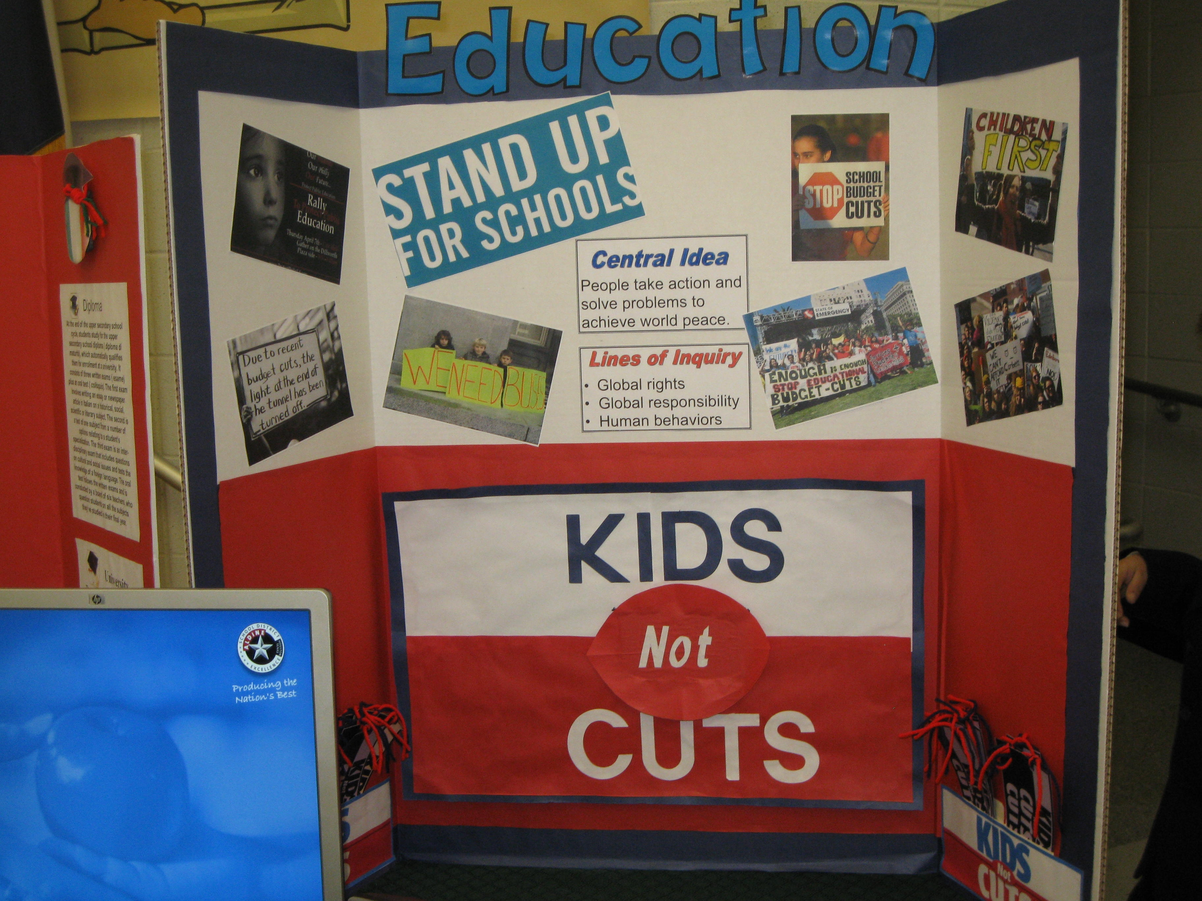

**Fifth graders present their research projects at the IB expo.**



In the present IB unit “How We Organize Ourselves” we are looking at the structure and function of organizations. How individuals have created systems that have impacted our society such as the metric system of measurement and various societal and political systems. We have also been learning about how our planet is geographically organized, which help us organize the way we look at the world.

Through the implementation of our unit activities, our students have the opportunity to put into practice our IB learner profiles and their various attributes:

Knowledgeable Inquirers

Communicators Thinkers

Open-minded Principled

Caring Risk-takers

Balanced Reflective

The following IB attitudes are also taught and promoted in order to help your child become an exemplary citizen:

**Cooperation** Enthusiasm   **Appreciation**

**Tolerance** Integrity     **Compromise**

Respect  Confidence  Creativity

  Empathy  Independence Curiosity

***The Fifth Grade Teachers***

We're learning...

Rato